**ECONOMY**

**OF**

**ISRAEL**

**SECTORS OF ISRAELI ECONOMY**

Israel is today an industrialized country with most of its manufacturing, including many traditional fields, based on intensive and sophisticated research & development and hi-tech processes, tools, and machinery..The growth of the nation is closely correlated with its educated workforce, as research and development in many areas has spurned growth.

Here are the strongest parts of their economy,

* **Technology**

The fastest growth rates are to be found in the hi-tech sectors. These sectors are skill and capital intensive and require sophisticated production techniques, as well as considerable investment in research and development, on which 4.9 percent of Israel's GDP is spent - the highest among OECD countries. The quality of this R&D in Israel is ranked, according to U.N. experts, among the first 10 in the world. A successful contribution to all these is due to academic research institutes, which provide much of the basic R&D, and venture capital.The number of new start-ups is very high due to the extraordinary innovative talent in Israel, coupled with the availability of highly skilled manpower

* **Mining and Manufacturing**,Israel also has robust mining and manufacturing sectors. Also, potassium nitrate and phosphoric acid are two major exports from a plant in Haifa and oil pipelines run to the Mediterranean Sea as well. Israel is a leading world diamond manufacturing and trading center. the Israeli diamond industry is a world leader in both cutting-edge technologies and craftsmanship, thus ensuring the best yield of polished diamonds from the rough.

* **Tourism**

Israel is a popular spot for worldwide visitors, and the growth of the tourism industry has helped fuel the nation’s economy. Although this industry contributes less than 3% to the GNP, it has a foreign currency added value of 85 percent (making it the added-value leader among the country's export industries) and employs some 80,000 persons. This industry's large potential is yet to be exploited, as it is a major factor in Israel's economic growth plan.

* **Transportation**

Israel’s developed transportation system pays major dividends in its economic success. The highway system enables citizens to move freely and efficiently. Israel has three deepwater ports (two on the Mediterranean Sea and one of the Red Sea), and those provide access to the Atlantic and Indian oceans. Air transport has also helped play a role in the export of high-value goods from the high-tech sector.

* **Agriculture**

Israel’s agricultural sector is characterized by an intensive system of production for overcoming the scarcity in natural resources, particularly water and cultivable land. The constant growth in agricultural production is due to the close cooperation and combined effort of researchers, farmers, and agriculture-related industries. Together they have developed and are applying new methods in all agricultural branches. The result is modern agriculture in a country more than half of whose area is desert. Their main agriculture products are citrus, vegetables, cotton, poultry etc.

**TOP ISRAELI COMPANIES**

* **StoreDot - battery charger**
* **Mobileye- car crash detector**
* **Cortica - image identification platform**
* **Gett - ride-hailing service**
* **Waze- navigation app**
* **Mindspace - workspace provider**
* **Flytrex - drone delivery service**
* **Viber - instant messaging platform**
* **Airobotics - surveillance and industrial drones**
* **Via - ride-sharing service**

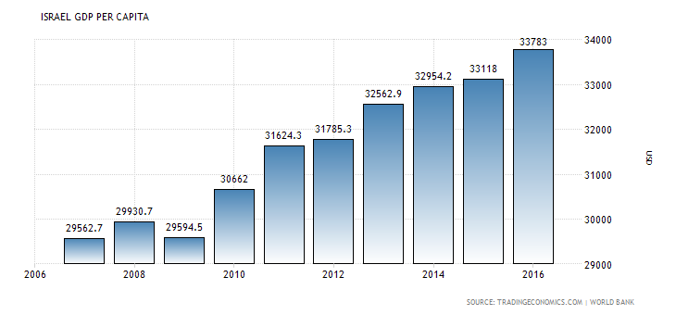

**ISRAEL GDP PER CAPITA**

**SOME QUICK ‘GDP’ FACTS**

* GDP growth rate = 0.70%
* GDP annual growth rate = 2.9%
* GDP growth annualized = 2.7%
* GDP per capita = 33783.00 (USD)
* GDP per capita PPP = 32612.7 (USD)
* GDP constant prices = 309608.70 (ILS Million)
* Gross National Product = 310905.90 (ILS Million)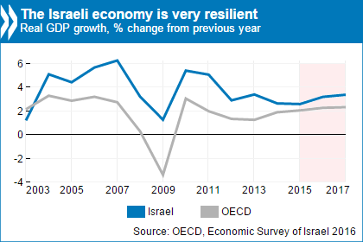

**ISRAEL IS EXPECTED TO BECOME WORLD’S 15TH BIGGEST ECONOMY BY 2025!**

**EXPORTS AND IMPORTS**

1. **According to Economic Complexity Index (ECI), Israel is the 42nd largest export economy in the world.**
2. **In 2015, Israel exported $65.4B and imported $59.9B**
3. **Their exports data is as follows**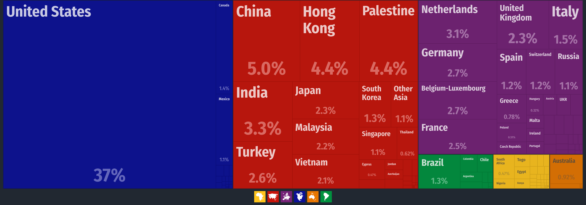

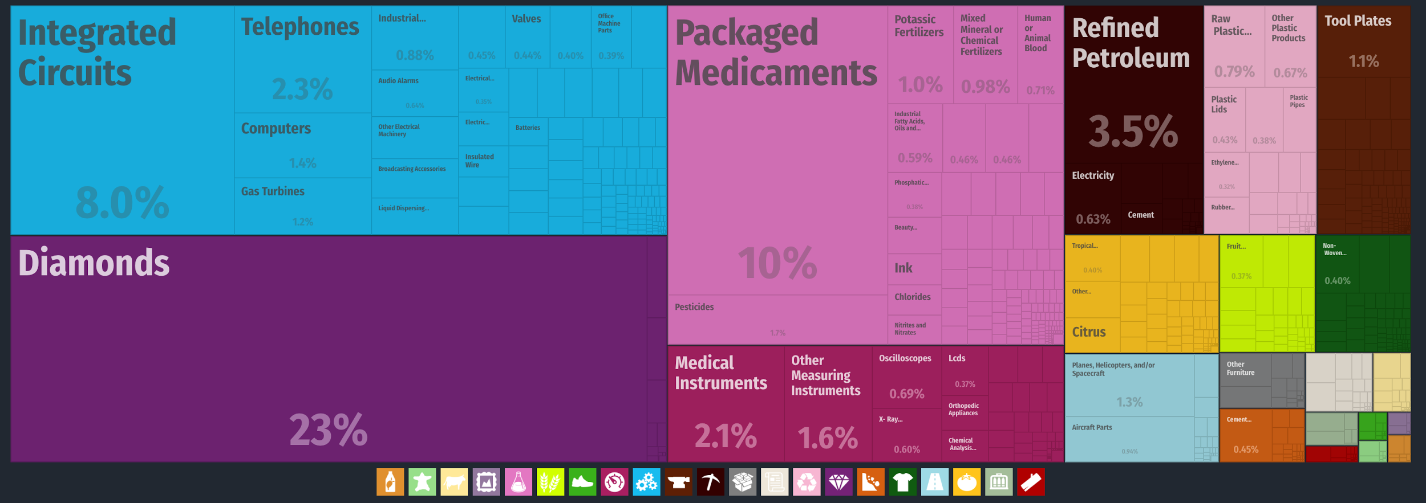

**4. Their import data is as follows**

